Mini Project :
Predictive Demand Schema Architecture for Food-Tech Analytics
Problem Statement :
“ Design a normalized, high-performance relational database architecture optimized for real-time feature extraction for restaurant success prediction models. ”
Dataset : Zomato Bangalore Restaurants Dataset
Data Source : https://www.kaggle.com/datasets/himanshupoddar/zomato-bangalore-restaurants
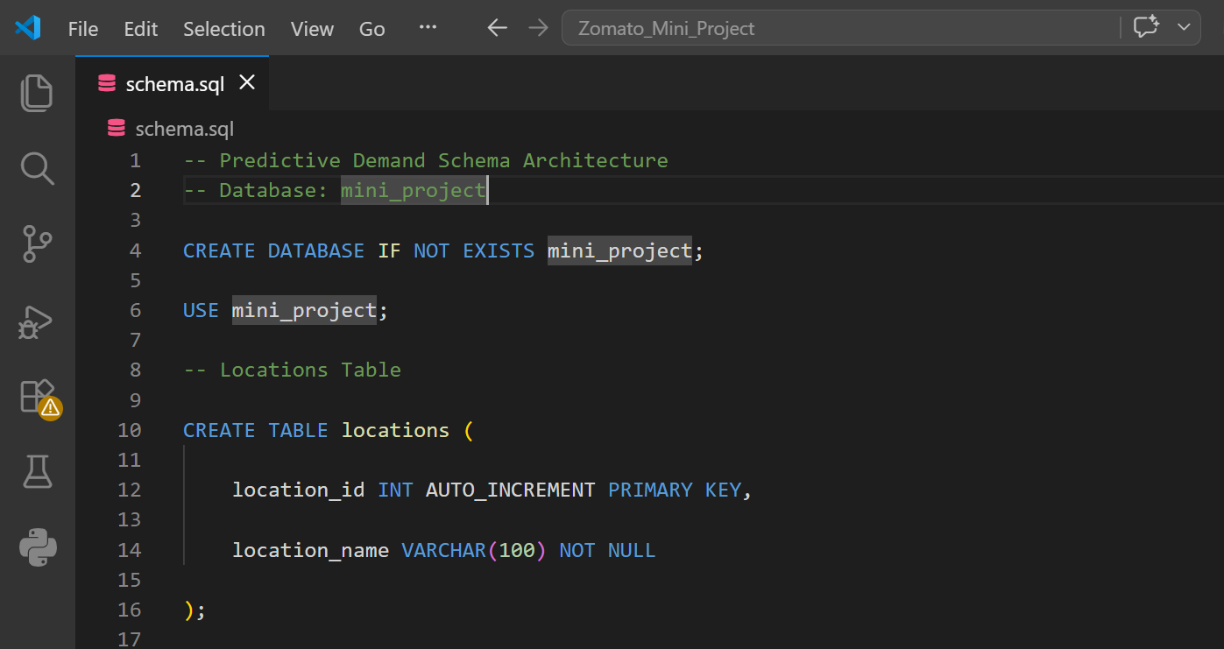
Optimized SQL DDL Script :
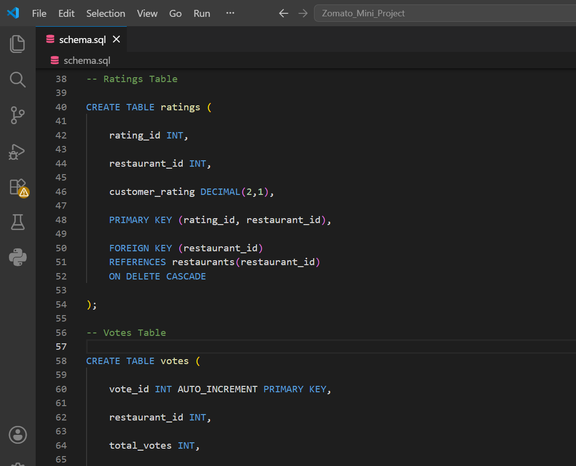
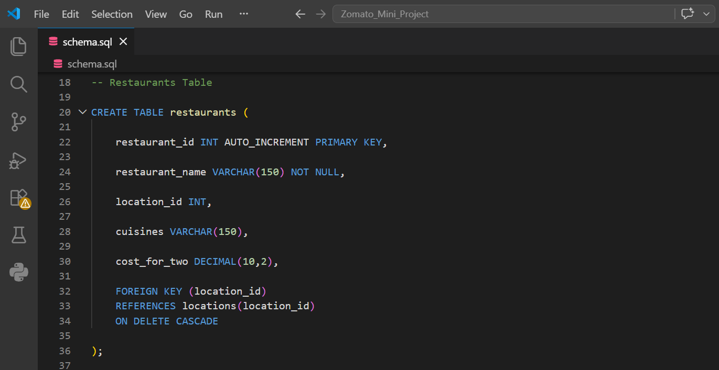
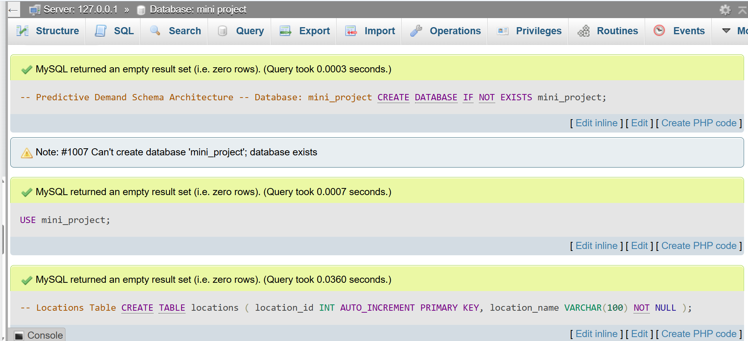
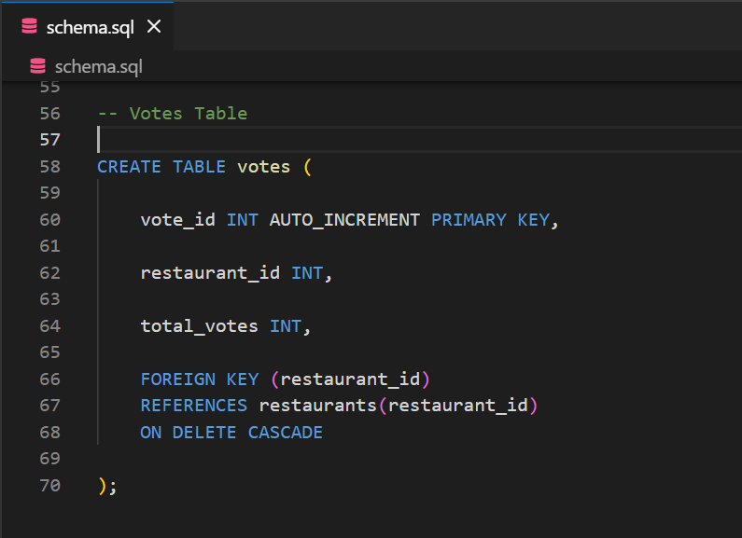
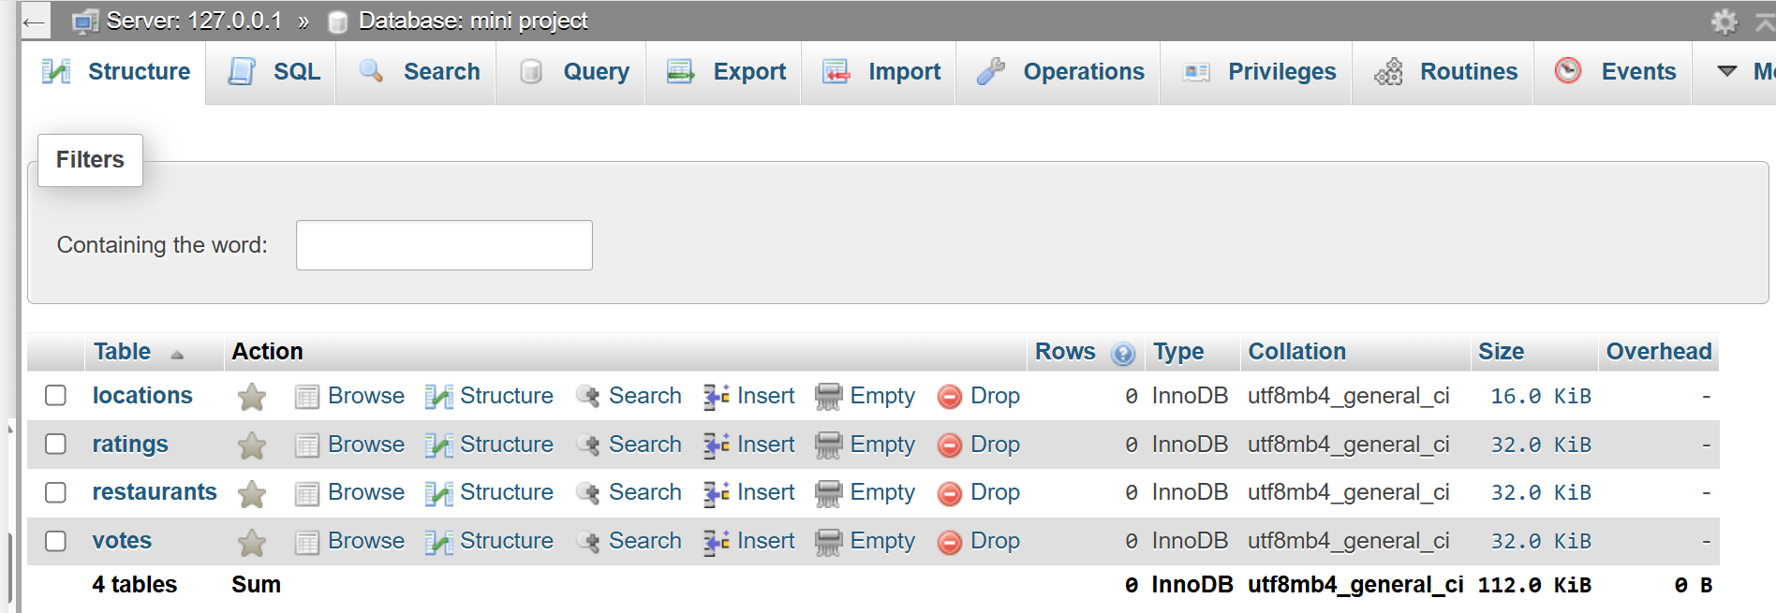
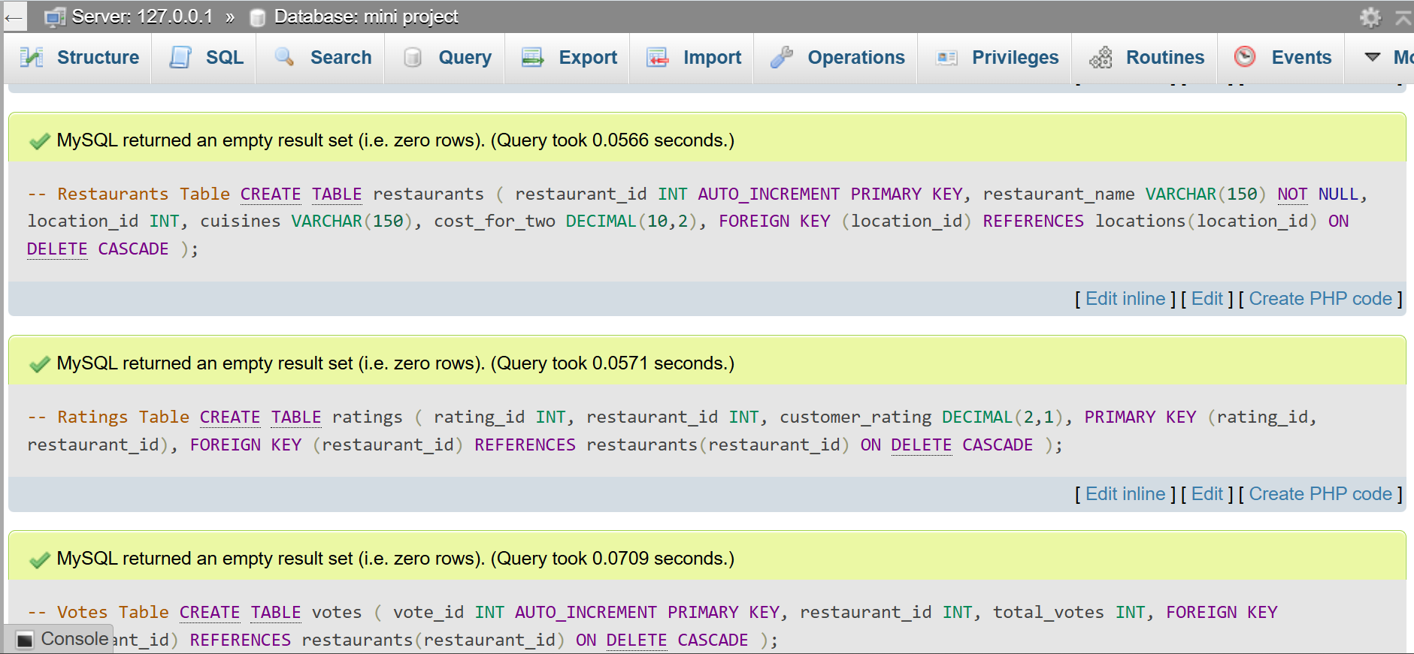
Explanation : “ The SQL DDL script creates a normalized relational database named mini_project. It defines the Locations, Restaurants, Ratings, and Votes tables using Primary Keys and Foreign Keys with ON DELETE CASCADE to maintain referential integrity ”

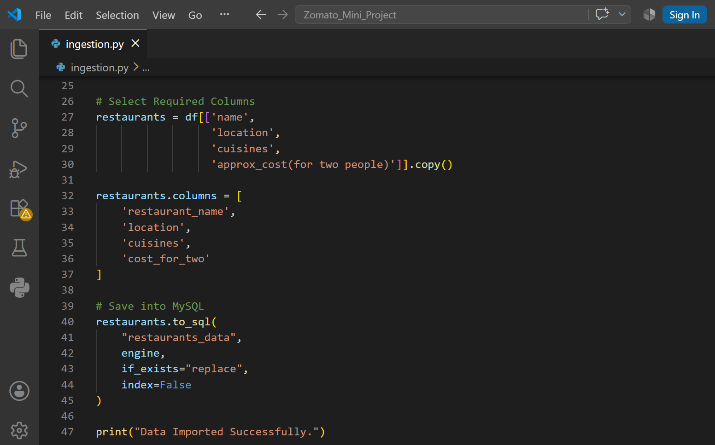
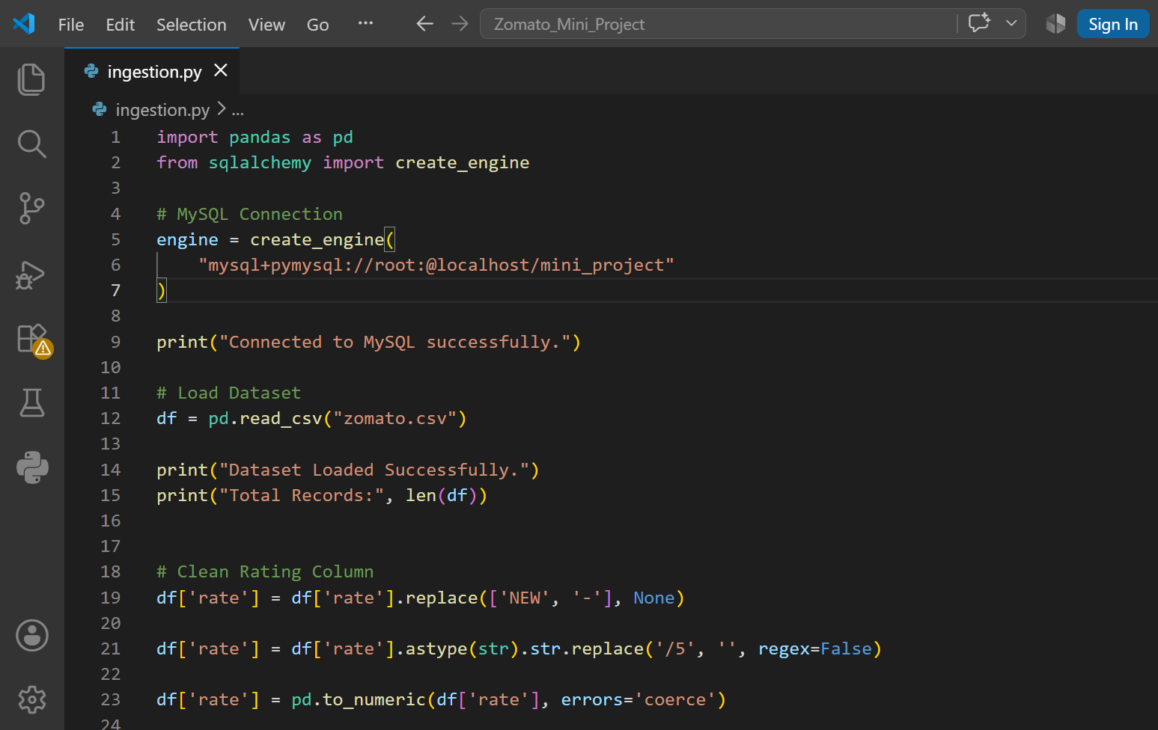
Python-based Data Ingestion Pipeline :
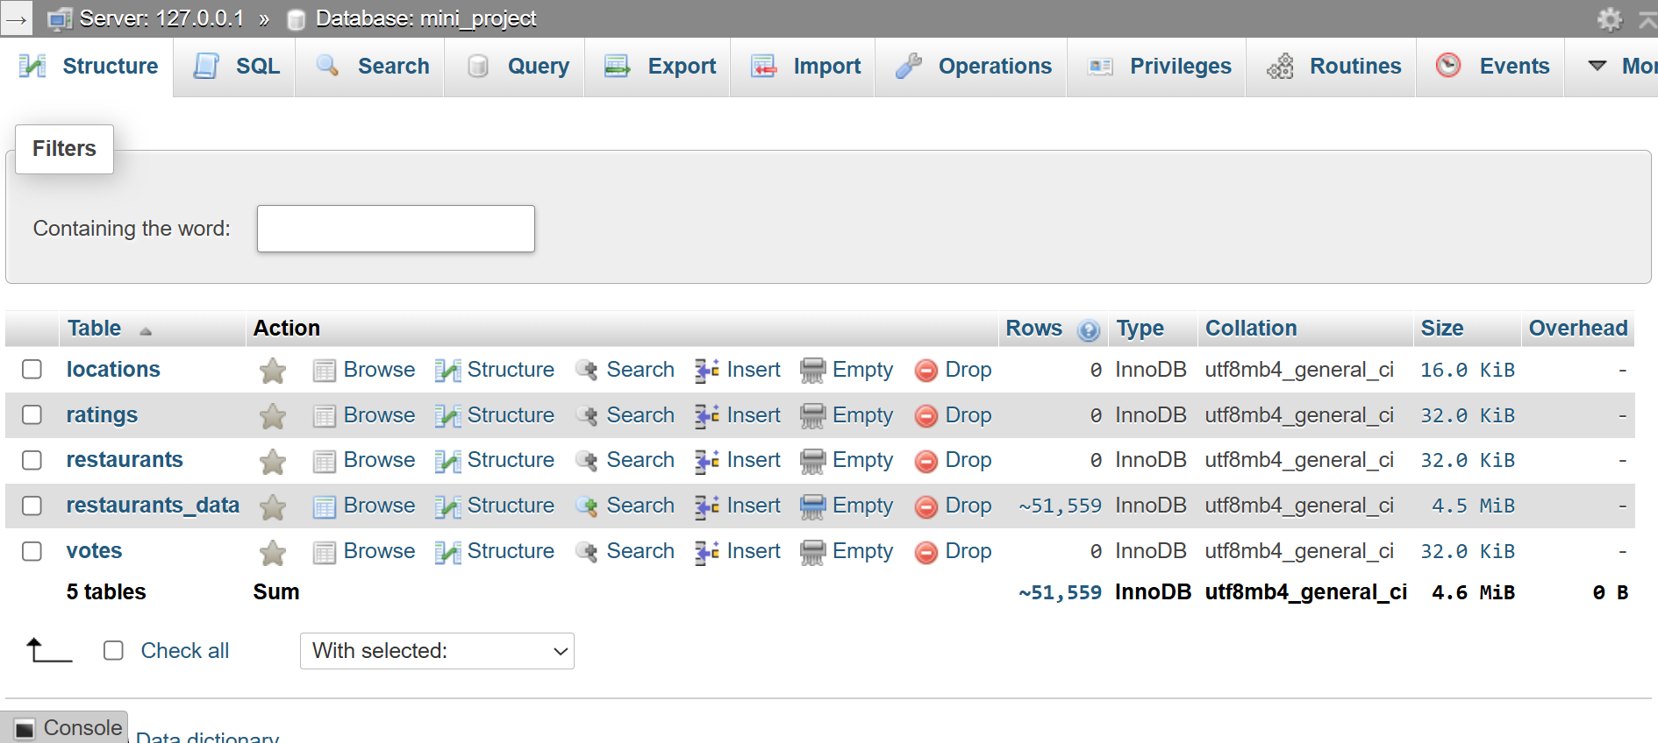
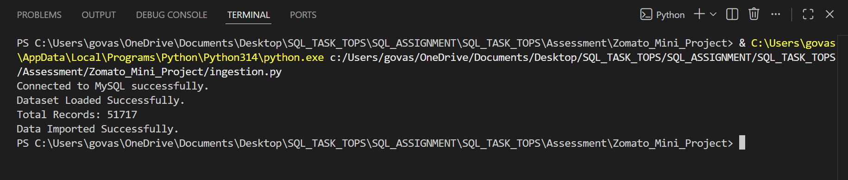
Explanation :
“ The Python data ingestion pipeline reads the Zomato Bangalore Restaurants dataset using Pandas, cleans the rating values, selects the required columns, and imports the processed data into the MySQL database using SQLAlchemy. This automated ETL process reduces manual work and prepares the dataset for analytics and machine learning. ”
Deliverable ER Diagram :
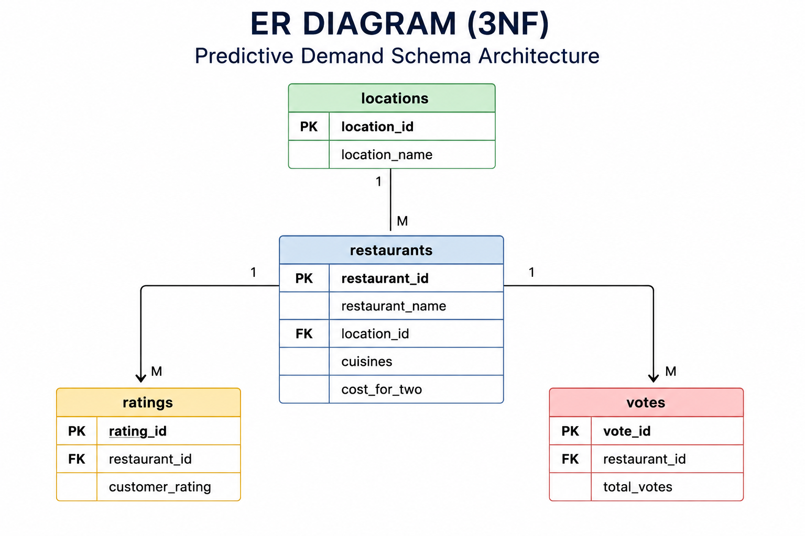

PK Primary Key

FK Foreign Key

1 : M One-to-Many Relationship

ER Diagram (3NF) Explanation :
“ The ER Diagram represents the normalized relational database design for the Zomato analytics project. The locations table stores location information, the restaurants table stores restaurant details, while the ratings and votes tables store customer ratings and voting information. The relationships are designed using Primary Keys and Foreign Keys to maintain Third Normal Form (3NF), reduce data redundancy, and improve query performance “

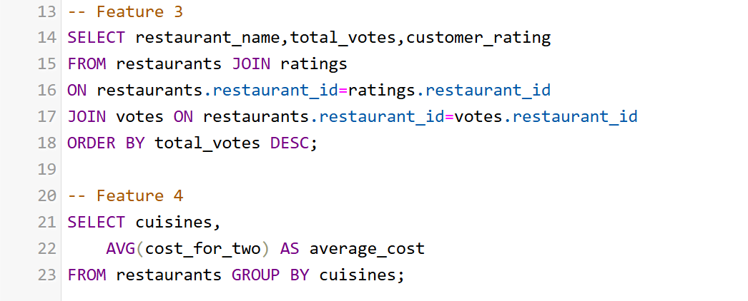
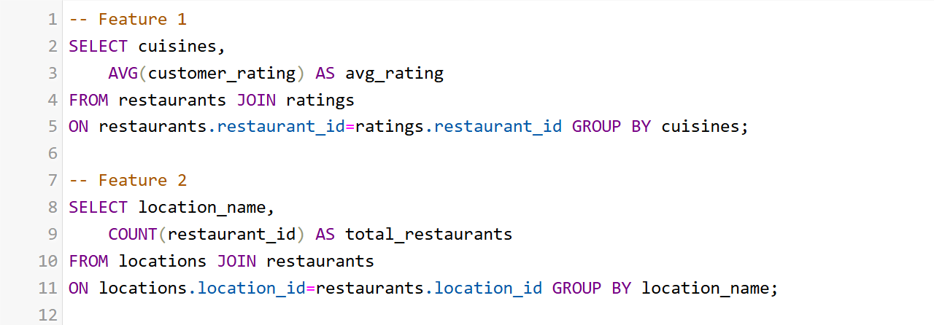
SQL-based Feature Engineering Report :
Zero Rows Select :
Reason….” The original SQL feature engineering queries were written using the restaurants, ratings, locations, and votes tables. However, these tables did not contain any records, so all JOIN operations returned 0 rows. The Zomato dataset was imported into the restaurants_data table using the Python data ingestion pipeline. Therefore, the feature engineering queries were modified to use the populated restaurants_data table, which contains 51,717 records, ensuring meaningful analytical results. ”

Feature 1 –Totel Number of Restaurants by Location
SELECT location,
COUNT(*) AS total_restaurants
FROM restaurants_data GROUP BY location
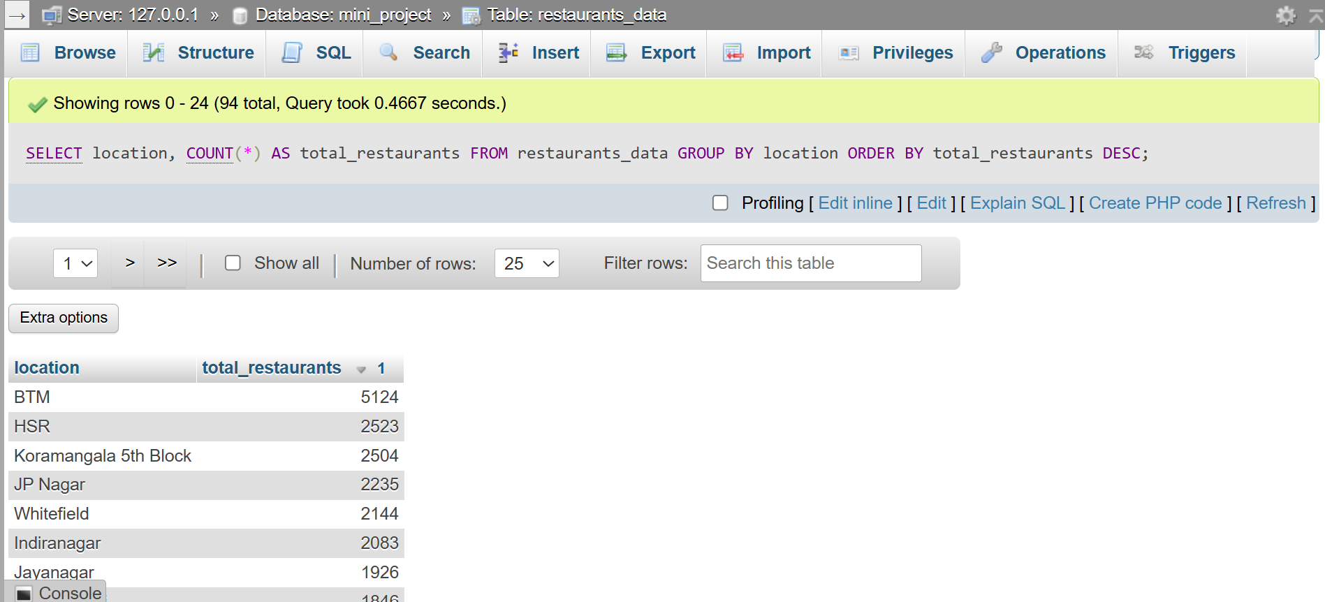
ORDER BY total_restaurants DESC ;

Feature 2 – Average Cost by Cuisine

Explanation : This query calculates the average cost for two people for each cuisine.

SELECT cuisines,
AVG(cost_for_two) AS average_cost
FROM restaurants_data
GROUP BY cuisines
ORDER BY average_cost DESC;
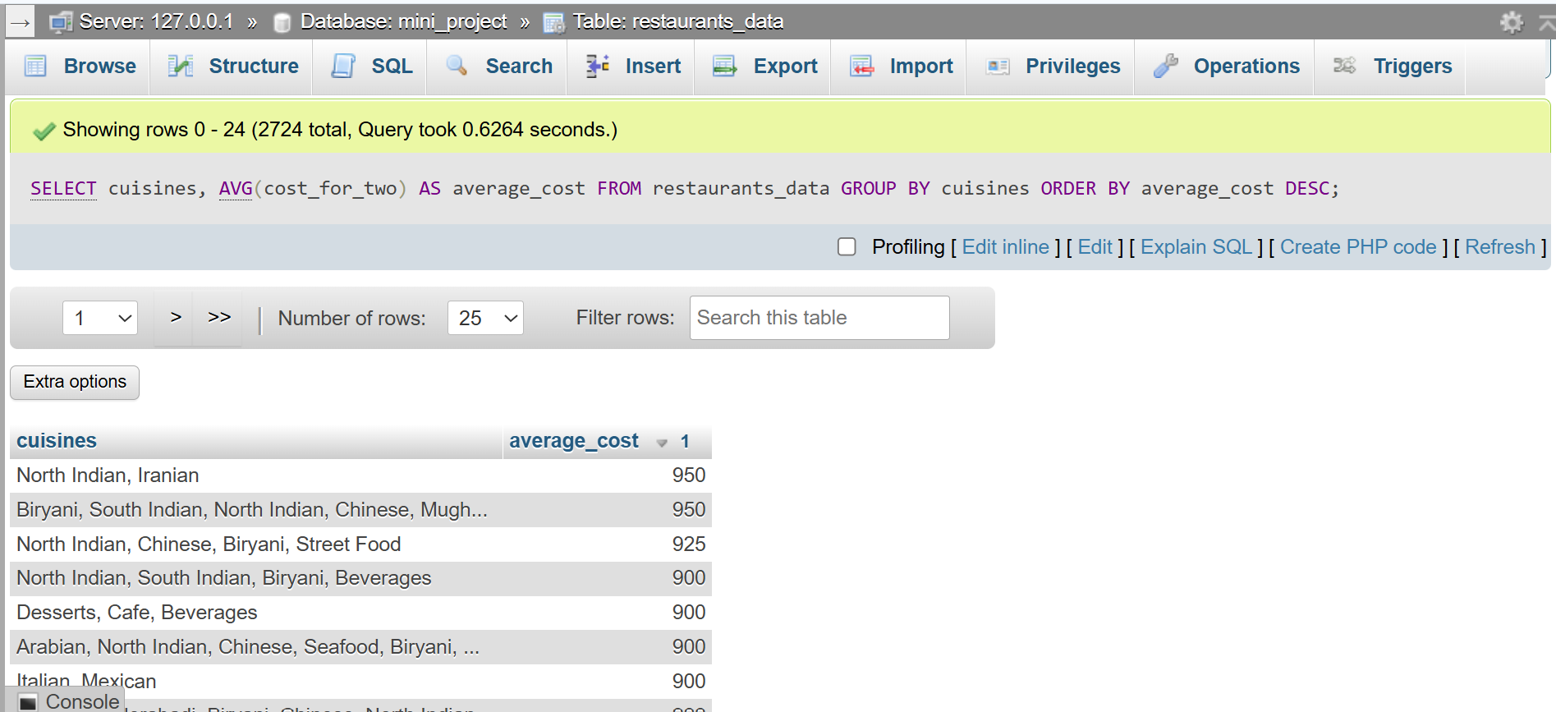

Feature 3 – Restaurants by Cuisine

Explanation : This query counts the number of restaurants serving each cuisine

SELECT cuisines,
COUNT(*) AS total_restaurants
FROM restaurants_data
GROUP BY cuisines
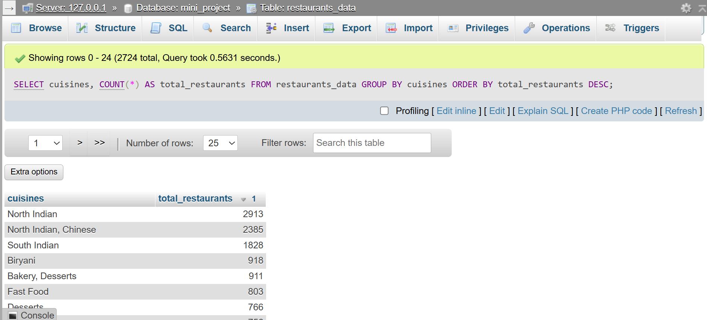
ORDER BY total_restaurants DESC;

Feature 4 – Top 10 Most Expensive Restaurants

Explanation : This query displays the top 10 restaurants with the highest approximate cost for two people…

SELECT restaurant_name,location,cost_for_two
FROM restaurants_data
ORDER BY cost_for_two DESC
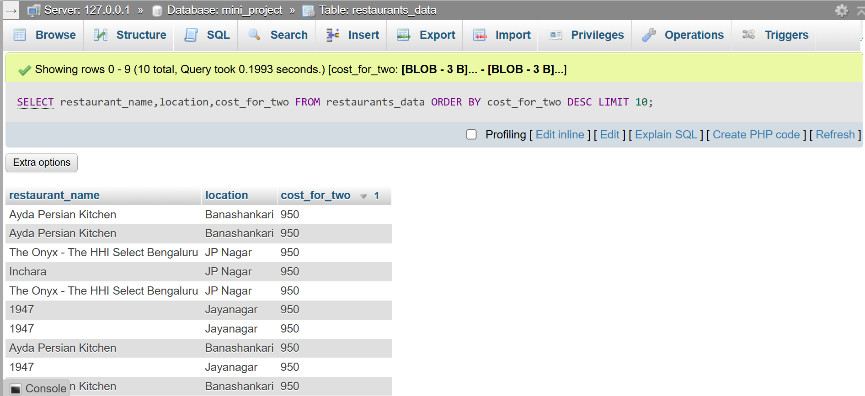
LIMIT 10;

Conclusion :
“ The mini project successfully demonstrates the design of a normalized relational database for the Zomato Bangalore Restaurants dataset. A SQL schema was created, the dataset was imported using a Python ETL pipeline, an ER Diagram was designed in 3NF, and SQL feature engineering queries were performed for analytical insights. The final database architecture is suitable for restaurant analytics and can support predictive machine learning models for restaurant success prediction . ”

